décrire des images; skriv och berätta om bilden på franska; vem är dessa personer? vad pratar de om? hur gamla är de? var är de? vad har de ätit? vad heter de? vad har de haft för yrken? etc

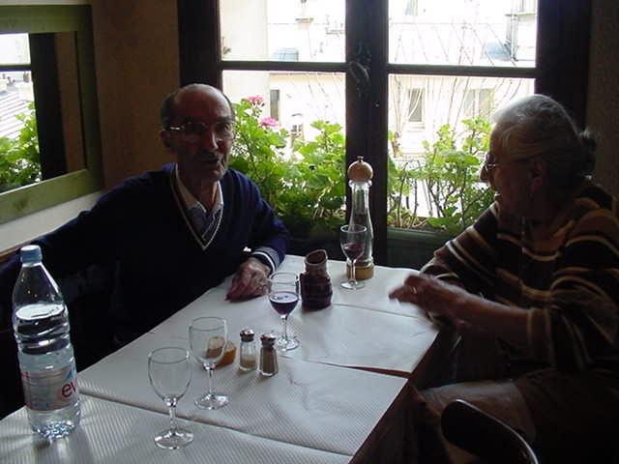

______________________________________________________________________________________

______________________________________________________________________________________

______________________________________________________________________________________

______________________________________________________________________________________

______________________________________________________________________________________

______________________________________________________________________________________

______________________________________________________________________________________

______________________________________________________________________________________

______________________________________________________________________________________

______________________________________________________________________________________

______________________________________________________________________________________

______________________________________________________________________________________

______________________________________________________________________________________

______________________________________________________________________________________

______________________________________________________________________________________

Skriv ut rätt städer på kartan:

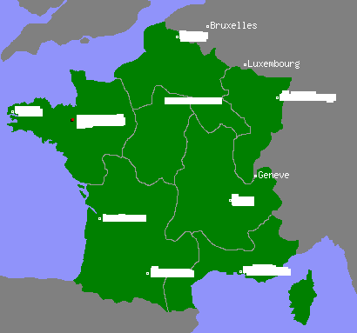

Gör minst 10 positionsmeningar med bilden på nästa sida:

______________________________________________________________________________________

______________________________________________________________________________________

______________________________________________________________________________________

______________________________________________________________________________________

______________________________________________________________________________________

______________________________________________________________________________________

______________________________________________________________________________________

______________________________________________________________________________________

______________________________________________________________________________________

______________________________________________________________________________________

______________________________________________________________________________________
